Assignment 8
Que1. Design a Cognitive Assistant for Reading Labels of medicine bottle
ans.
Model:
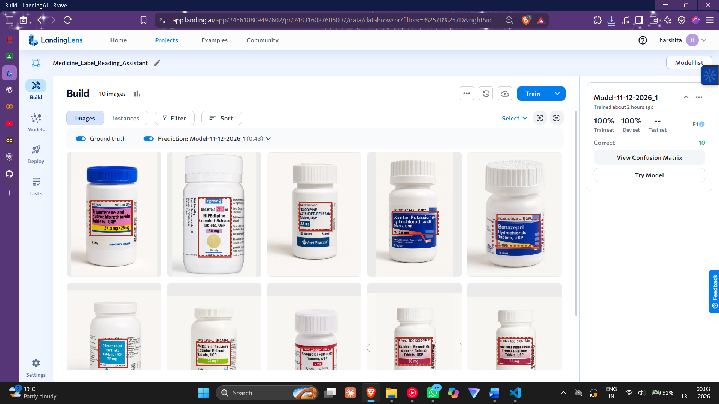

Testing the model:
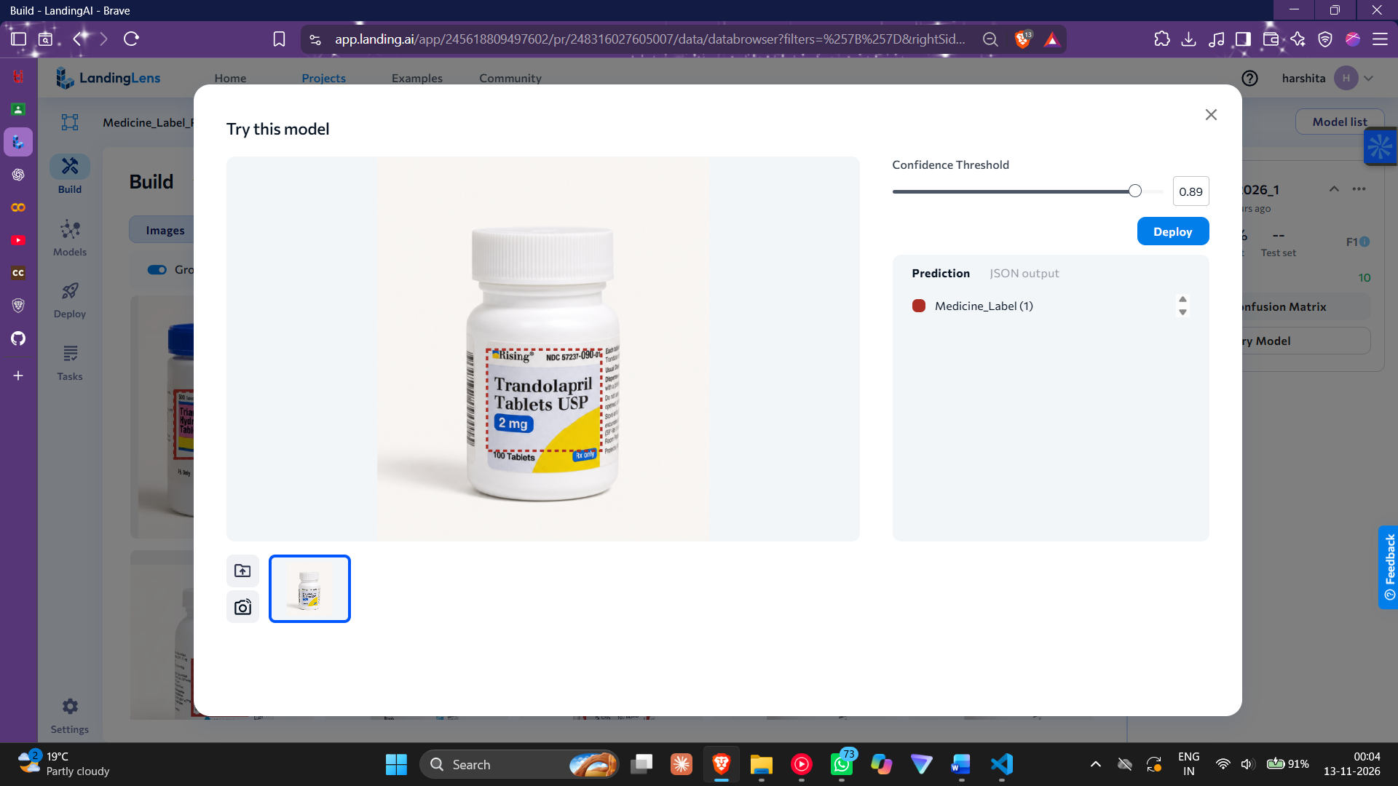

Full report:

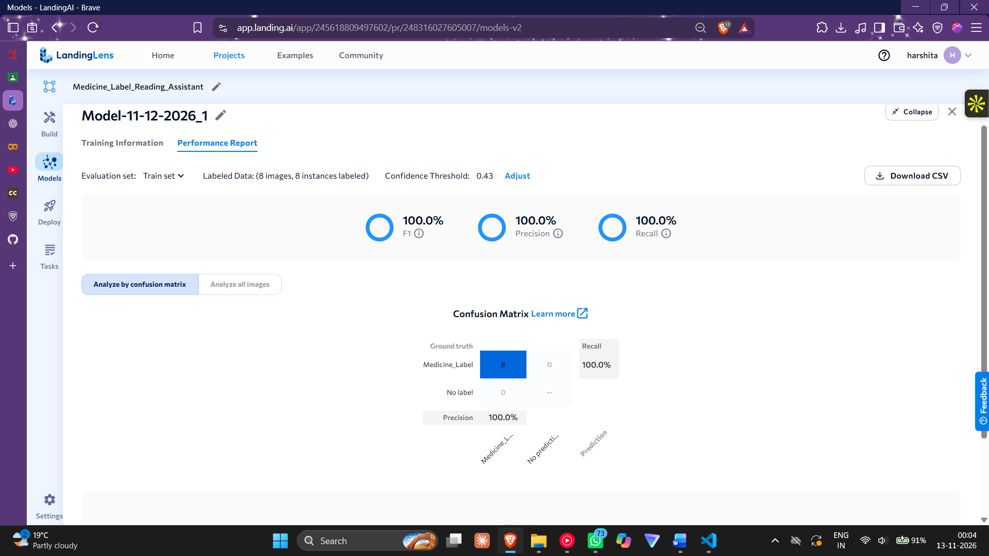

Que2 .Design an Emotion-aware Cognitive Assistant using Facial Expression Detection .
ans.
Model:
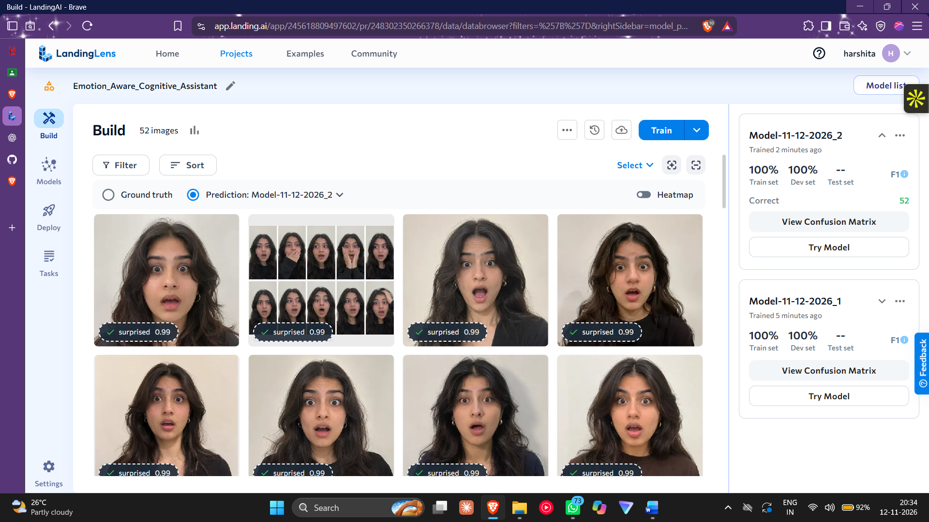
Testing the model:
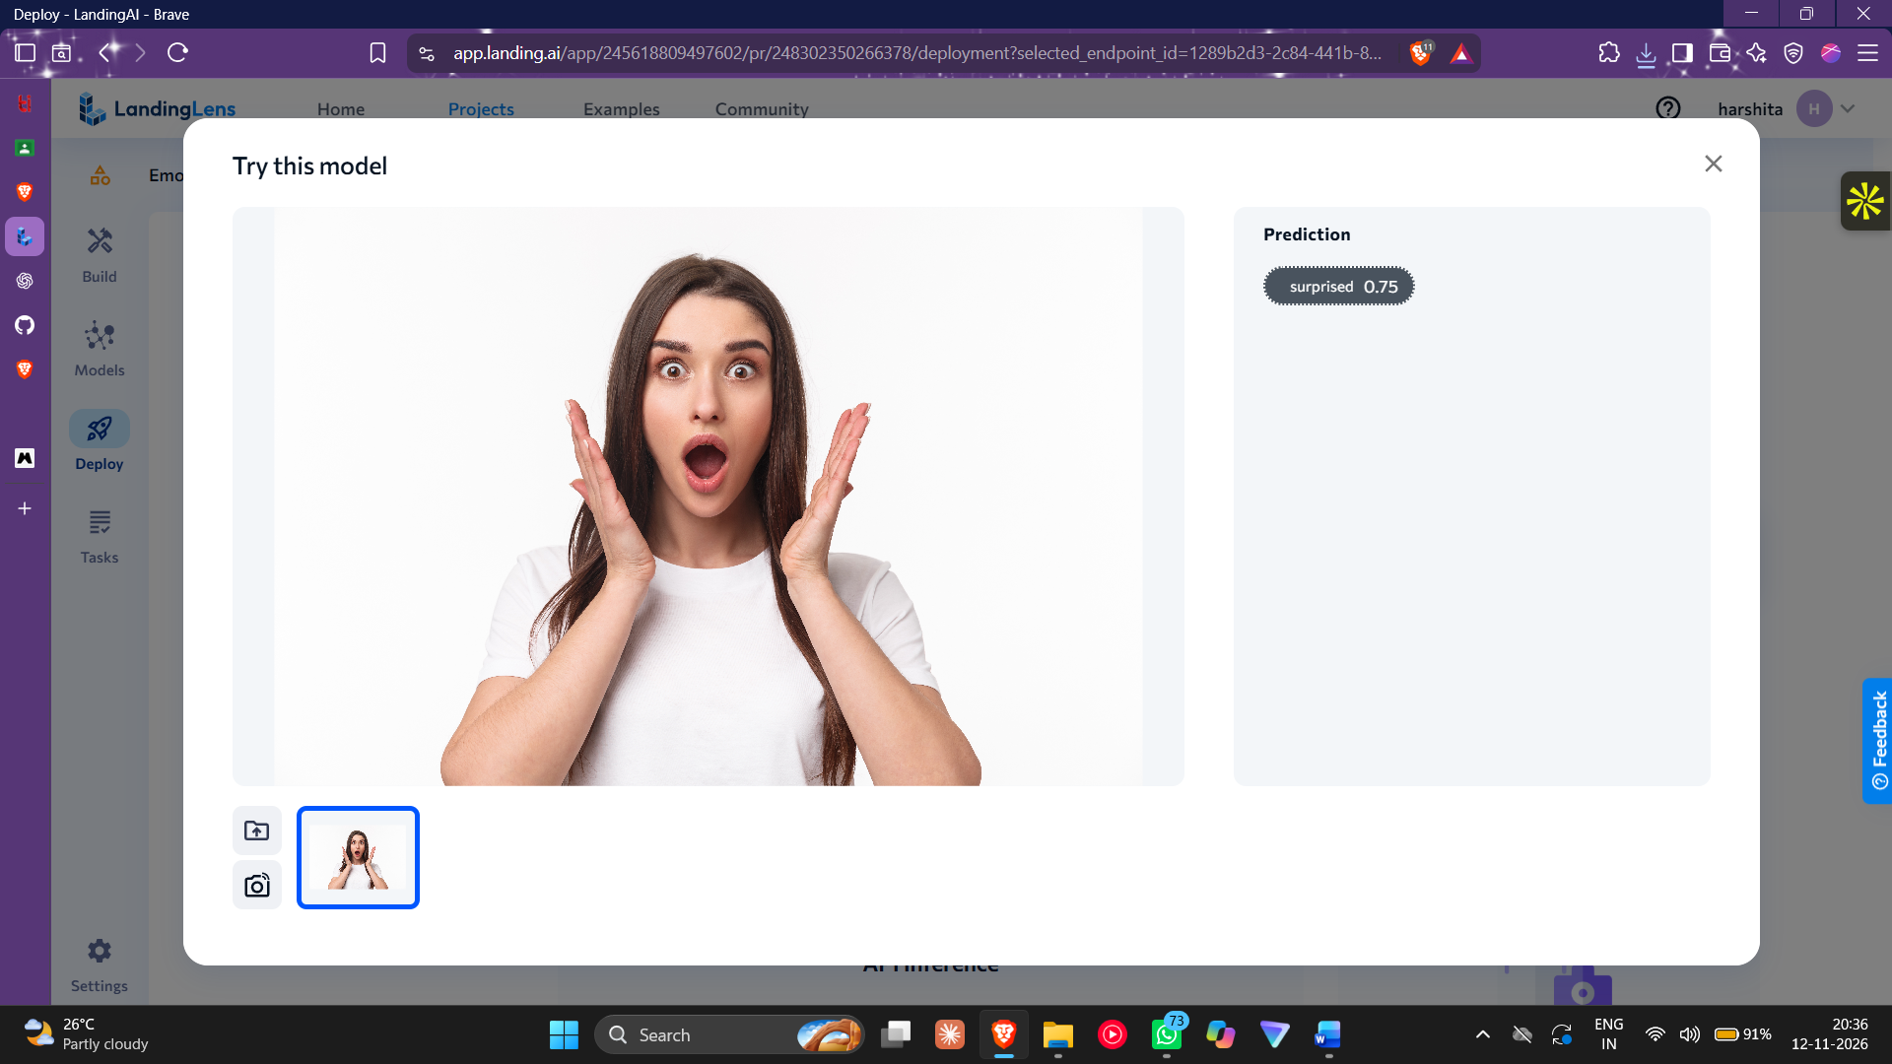
Full report:


